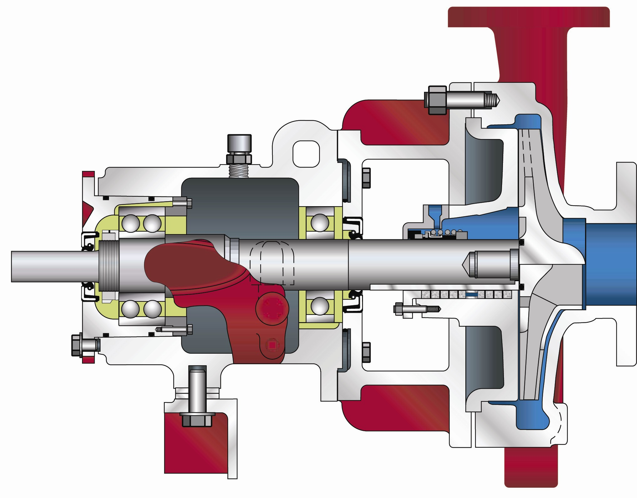
The advanced design and precision manufacture of the rugged, heavy-duty OSD petrochemical service pump significantly enhance bearing and seal life. American-Marsh Pumps is committed to helping users maximize mean time between planned maintenance (MTBPM). American-Marsh Pumps’ unique features and enhancements provide significant performance benefits for pump users. Some features of the OSD resulted from the suggestions of working engineers in the field, and were combined with others derived from the broad experience of American-Marsh engineers. Thus practical features, backed by over 130 years of quality pump manufacturing, assure you of excellent pump performance and full satisfaction.
PRODUCT BULLETINCOMMERCIALINDUSTRIAL
MODEL OSD ANSI PROCESSBoiler Feed, Transfer,Propane, Butane, Crude Oil, Acids, Gasoline, Naphtha, Organic,
Condensate ReturnPetrochemical, Black Liquor, Ammonia, Organic Fluids, Cargo Transfer
PRODUCT BULLETIN
MODEL OSD ANSI PROCESS

PART | CONSTRUCTION
PART | CAST STEEL CAST STEEL | CAST STEEL  316 SS | ALL 316 SS | ALL CD4MCU | ALL ALLOY 20
Casing | CAST STEEL | CAST STEEL | 316 SS | CD4MCU | ALLOY 20
Impeller | CAST STEEL | 316 SS | 316 SS | CD4MCU | ALLOY 20
Shaft | STEEL | 316 SS | 316 SS | ZC20 | ZC20
Seal Chamber | CAST STEEL | CAST STEEL | 316 SS | CD4MCU | ALLOY 20
Seal Gland | 316 SS | 316 SS | 316 SS | ALLOY 20 | ALLOY 20
Power Frame | CAST IRON | CAST IRON | CAST IRON | CAST IRON | CAST IRON

Casing: The casing is constructed of high tensile cast steel or other specified material. It is of the volute type, carefully and accurately proportioned to permit smooth flow and to convert high velocity energy of the fluid as it leaves the impeller into pressure. Suction and discharge nozzles are flanged and are cast integral with the volute. The casing has cast integral feet standard and the discharge port is of the vertical centerline type. The casing assembly fully meets ANSI B73.1 dimensional requirements. Necessary vent and drain openings can be provided upon request.
Impeller: The impeller is of the reverse vane, end suction type, casted in one piece of cast steel or other specified material. Running clearances need to only be adjusted between the back of the impeller and the casing adapter. This design allows for repeatable factory tolerances, all of which can be adjusted on the bench, not just in the field. All impellers are hydraulically and dynamically balanced prior to assembly. Front semi-open impellers can be supplied upon request. All model meets the stringent performance requirements of ANSI B73.1. AMP also offers 4 Low-Flow models to meet difficult low-flow/high-head process applications.
Shaft: The shaft is of high strength steel or other specified material, ground to accurate dimensions and polished to a smooth surface. It is designed for extra stiffness to avoid all critical speeds in operation. OSD pumps lead the industry in low L³/D⁴ ratio’s minimizing shaft deflection at the stuffing box. All OSD models guarantee less than 0.002” shaft deflection at the seal face location, while in operation. As an option, the shaft can be protected by a shaft sleeve of ample thickness to ensure long life. The shaft sleeve can be supplied in various materials.
Seal Chamber: The seal chamber is available in five (5) different configurations depending on the jobsite requirement. OSD pumps feature the Flow Modified (FM) seal chamber that keeps solid matter from collecting in the seal chamber causing premature seal failure. The FM bores are available in a small bore (FMS), a large bore (FML) and a small bore with cast integral gland (FMI), all designed to meet the process requirements of the seal industry. OSD models can also be supplied in a standard Cyclindrical Bore (CB) arrangement. The CB bores are available in a small bore (CBS) and large bore (CBL) both designed to meet the process requirements of the seal industry. Seal chambers have provisions for various flush plan arrangements customizing the seal chamber to meet the requirements of the end user. For abrasive applications, packing with a lantern ring can also be supplied. A wide variety of component and cartridge mechanical seals can be used with OSD standard components.
Power Frame: The power frame is constructed of high tensile ductile iron and provides support for the inboard and outboard bearings. The outboard bearing is of the double row, angular contact type and the inboard bearing is of the single row, deep groove type for excellent axial and radial load support. For axial adjustment of the impeller, the power frame employs a micrometer adjustment which allows the user to dial back factory tolerances between the impeller and the seal chamber. This re-adjustment of tolerances can be done on the bench, compensating for proper seal setting and eliminating the need to have the casing near for final adjustment. Double lip seals ensure that contaminents are kept out of the power frame. Upgraded bearing isolators can be supplied upon request. For extremely crucial applications, magnetic bearing isolators with a poppet breather can be specified, hermetically sealing the power frame. The power frame has an oversized, integral oil sump that provides oil for lubrication to each bearing. A large one inch oil level eye is provided standard on the power frame to visually indicate the oil level. The bearings and shafts are so designed to last up to 61% longer than the competition. With shaft deflection indicies surpassing nearly all of the competition, 43-252% greater stiffness is achieved resulting in longer Mean Time Between Planned Maintenance (MTBPM).

Item Number | Item Description |  |  | Item Number | Item Description
100 | Casing |  |  | 124 | Bearing Locknut
103 | Impeller |  |  | 125 | Bearing Lockwasher
104 | Impeller Gasket |  |  | 129 | Outboard Oil Lip Seal
105 | Shaft |  |  | 131 | Adapter O-Ring | N/A
106 | Rear Cover Plate |  |  | 133 | Trico Oiler
107 | Rear Cover Gasket |  |  | 134 | Bearing Housing Drain Plug
108 | Bearing Housing Adapter | N/A |  | 135 | Bearing Housing Vent Plug
109 | Bearing Housing Foot |  |  | 136 | Capscrew – Foot
109A | Shim |  |  | 139 | Capscrew – Bearing Housing | N/A
110 | Gland – Packing | OPT. |  | 140 | Capscrew – Cover/Adapter
111 | Stud – Gland |  |  | 153 | Mechanical Seal
111A | Hex Nut – Gland |  |  | 177 | Hook Sleeve | OPT.
112 | Lantern Ring Halves | OPT. |  | 190 | Gland – Mechanical Seal
113 | Packing | OPT. |  | 190G | Gland Gasket
114 | Inboard Deflector | OPT. |  | 200 | Oil Sight Gage
115 | Stud – Casing |  |  | 201 | Bearing Carrier
115A | Hex Nut – Casing |  |  | 201A | Set Screw – Bearing Carrier
118 | Inboard Oil Lip Seal |  |  | 201B | O-Ring – Bearing Carrier
119 | Bearing Housing |  |  | 201C | Bearing Carrier Retainer
120 | Inboard Bearing |  |  | 201D | Clap Ring Bearing Housing | OPT.
121 | Outboard Bearing |  |  | 201E | Socket Head Capscrew Clamp | OPT.
122 | Oil Slinger | OPT.
Recommended spare parts are in BOLD.
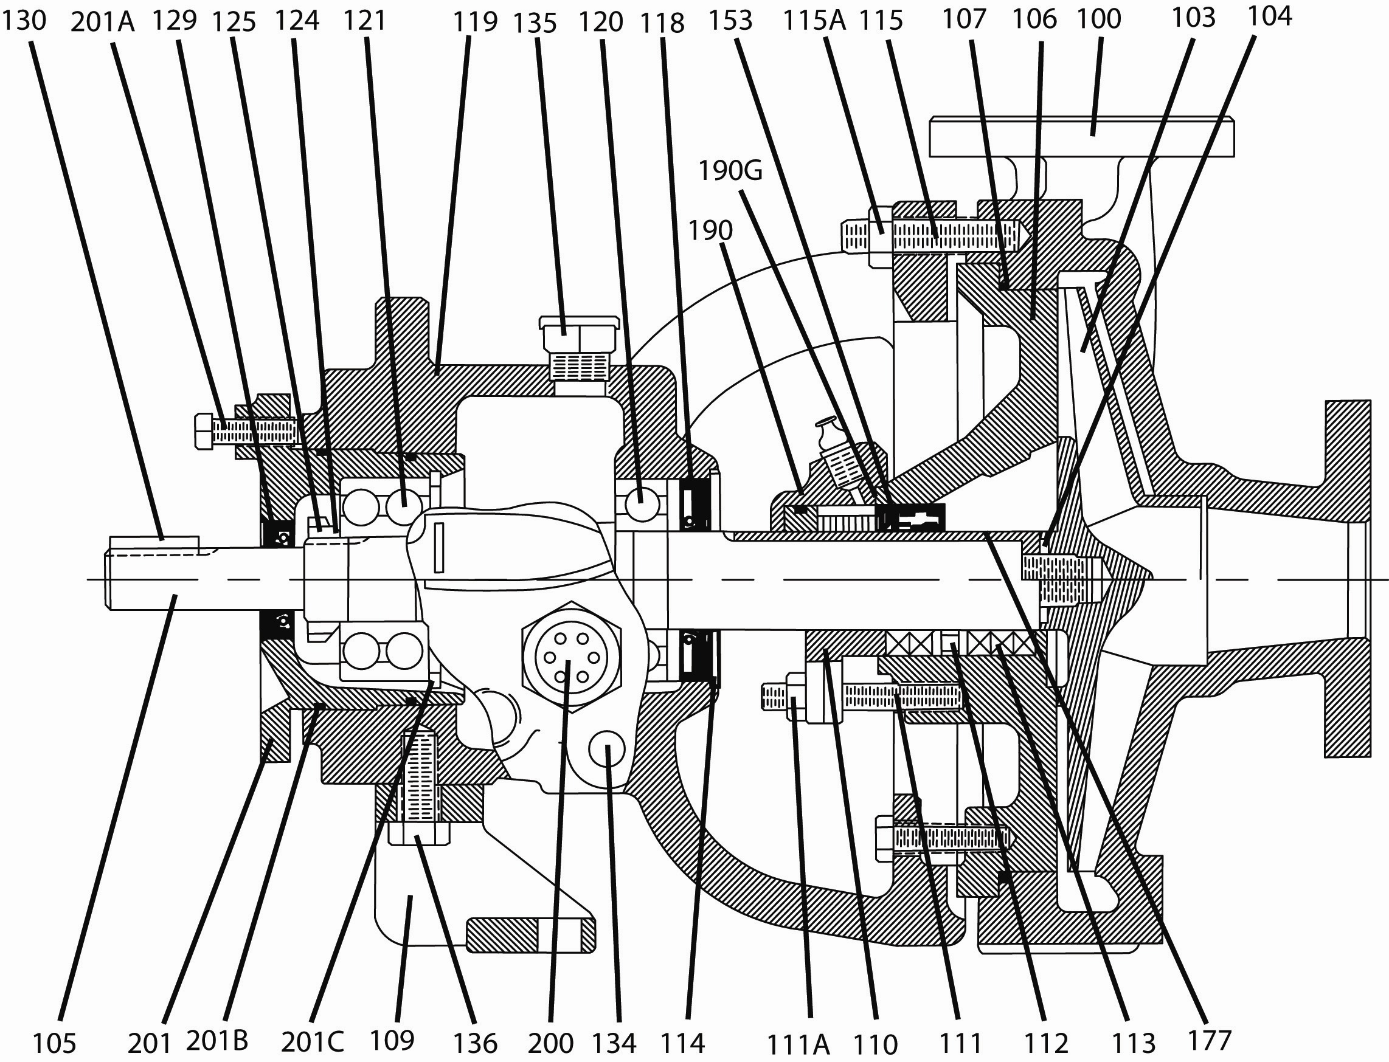

Item Number | Item Description |  |  | Item Number | Item Description
100 | Casing |  |  | 124 | Bearing Locknut
103 | Impeller |  |  | 125 | Bearing Lockwasher
104 | Impeller Gasket |  |  | 129 | Outboard Oil Lip Seal
105 | Shaft |  |  | 131 | Adapter O-Ring
106 | Rear Cover Plate |  |  | 133 | Trico Oiler
107 | Rear Cover Gasket |  |  | 134 | Bearing Housing Drain Plug
108 | Bearing Housing Adapter |  |  | 135 | Bearing Housing Vent Plug
109 | Bearing Housing Foot |  |  | 136 | Capscrew – Foot
109A | Shim |  |  | 139 | Capscrew – Bearing Housing | N/A
110 | Gland – Packing | OPT. |  | 140 | Capscrew – Cover/Adapter
111 | Stud – Gland |  |  | 153 | Mechanical Seal
111A | Hex Nut – Gland |  |  | 177 | Hook Sleeve | OPT.
112 | Lantern Ring Halves | OPT. |  | 190 | Gland – Mechanical Seal
113 | Packing | OPT. |  | 190G | Gland Gasket
114 | Inboard Deflector | OPT. |  | 200 | Oil Sight Gage
115 | Stud – Casing |  |  | 201 | Bearing Carrier
115A | Hex Nut – Casing |  |  | 201A | Set Screw – Bearing Carrier
118 | Inboard Oil Lip Seal |  |  | 201B | O-Ring – Bearing Carrier
119 | Bearing Housing |  |  | 201C | Bearing Carrier Retainer
120 | Inboard Bearing |  |  | 201D | Clap Ring Bearing Housing | OPT.
121 | Outboard Bearing |  |  | 201E | Socket Head Capscrew Clamp | OPT.
122 | Oil Slinger | OPT.
Recommended spare parts are in BOLD.
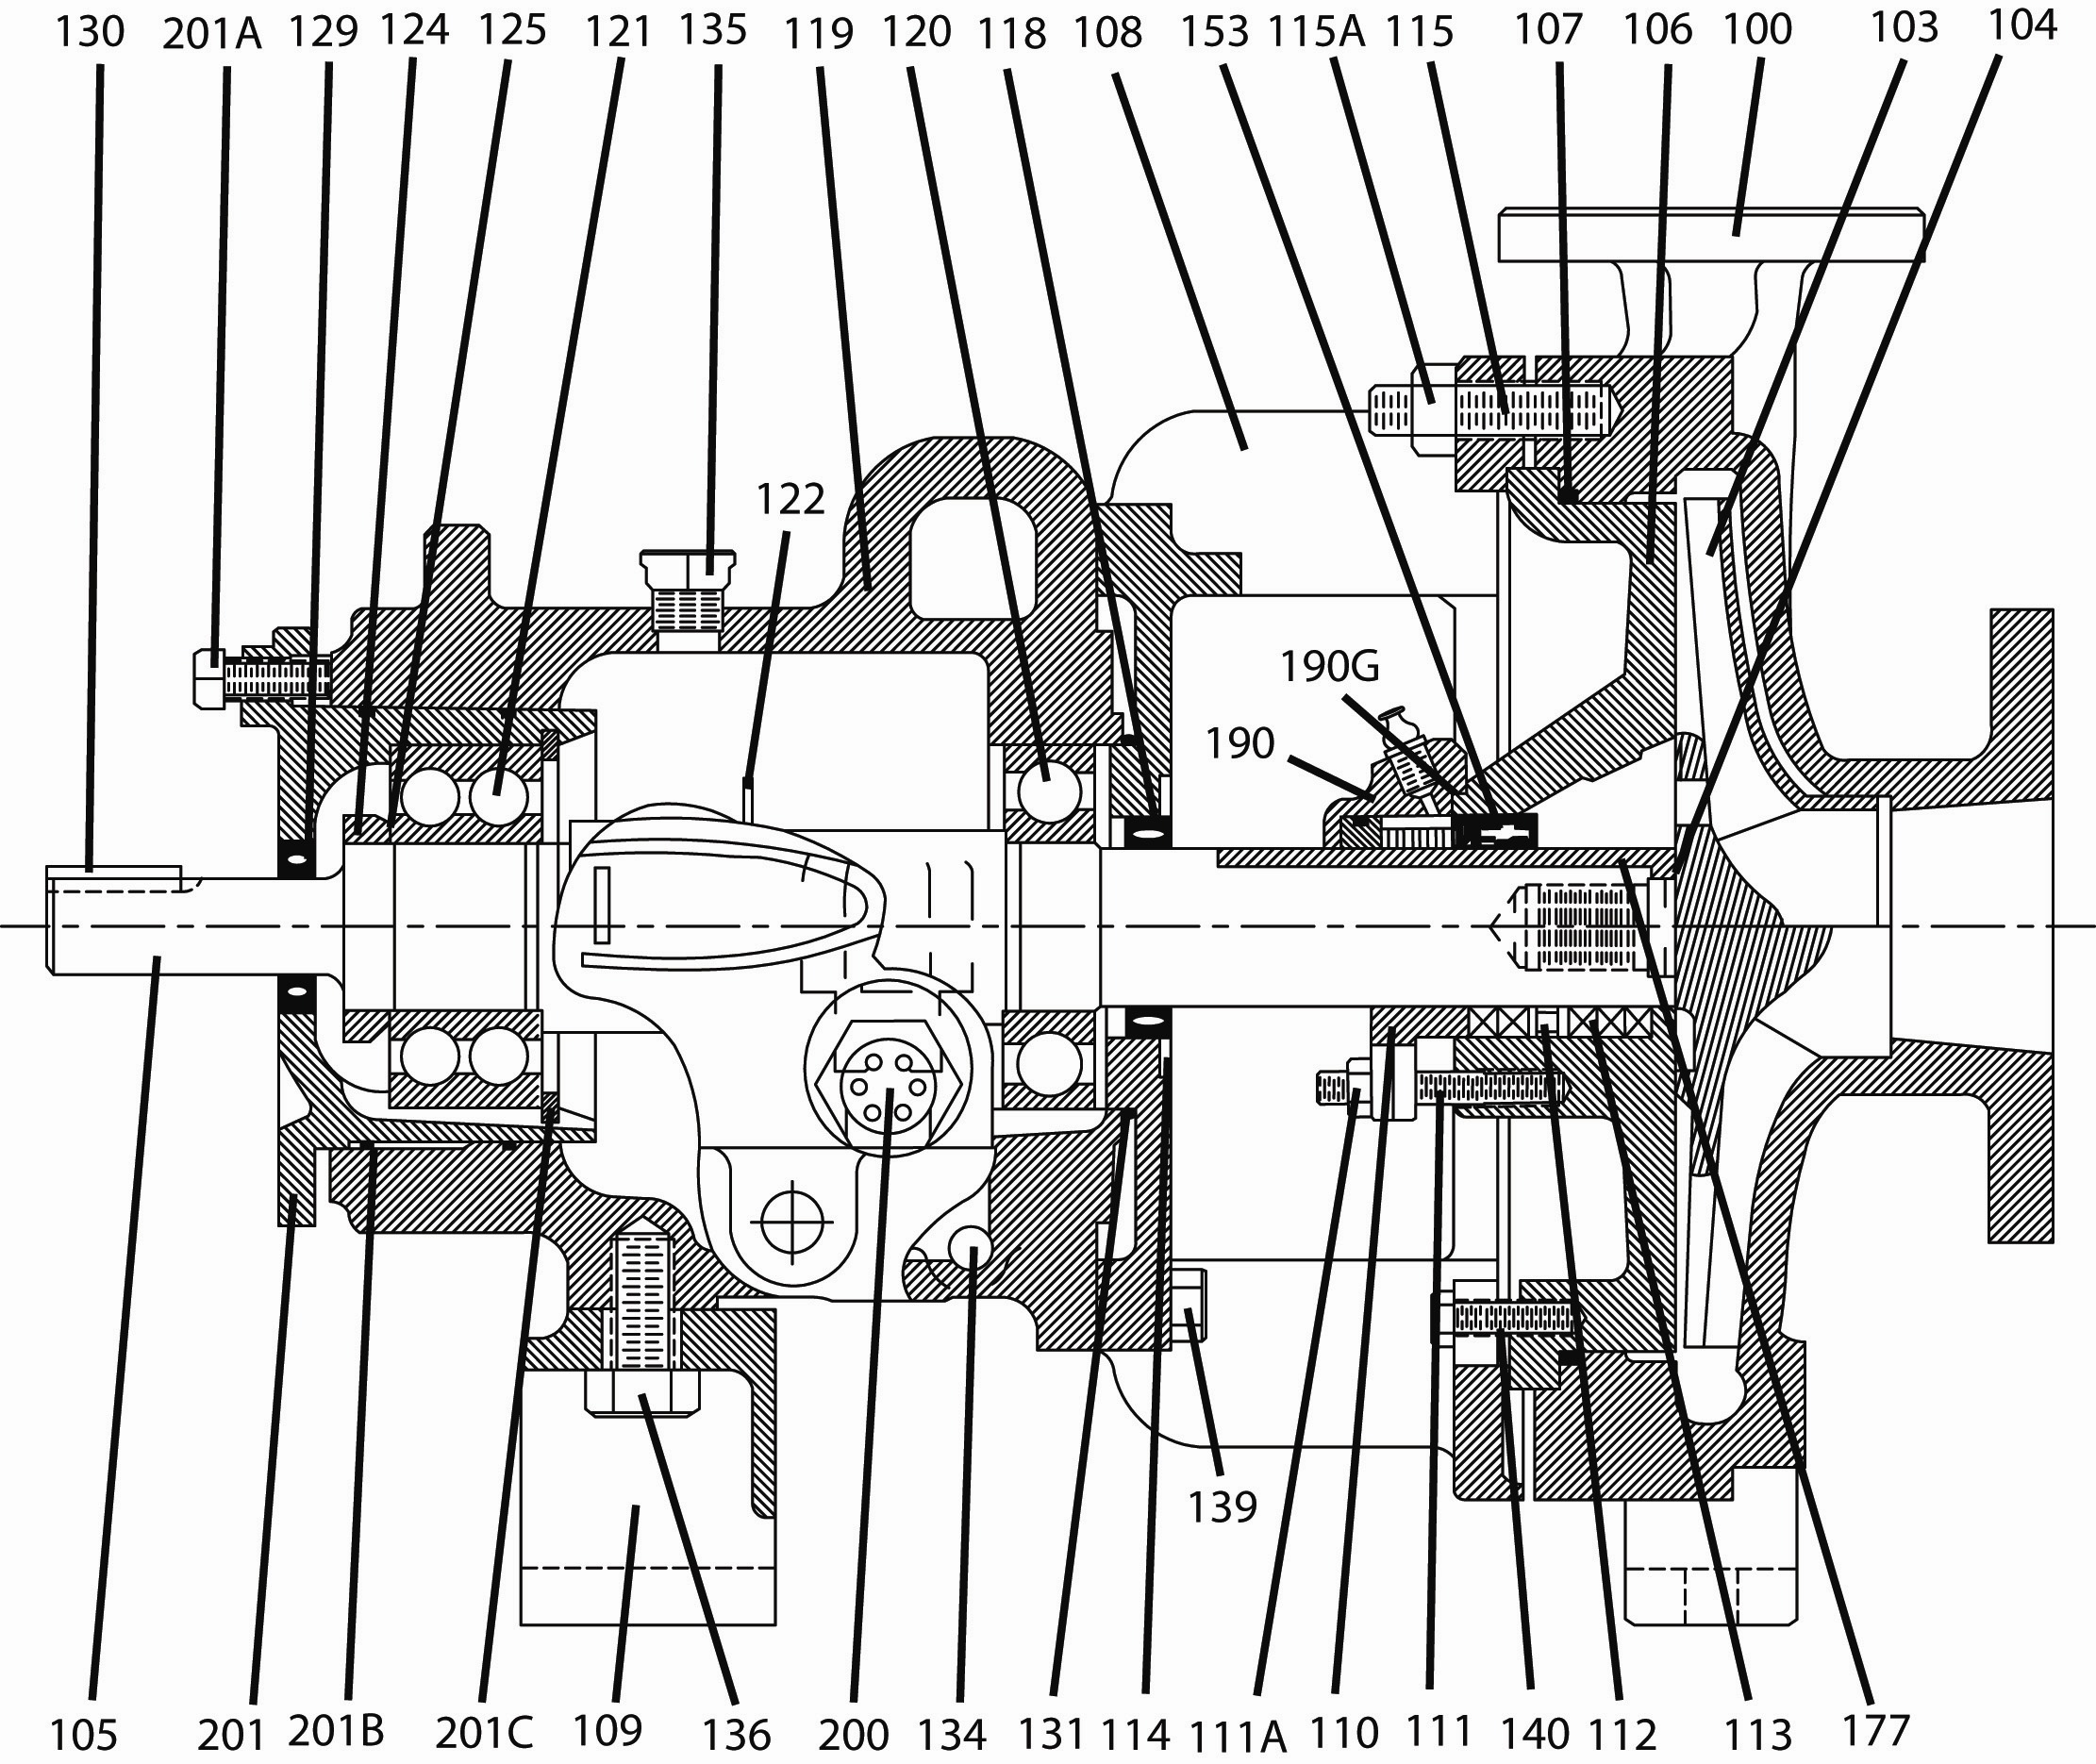

Item Number | Item Description |  |  | Item Number | Item Description
100 | Casing |  |  | 124 | Bearing Locknut
103 | Impeller |  |  | 125 | Bearing Lockwasher
104 | Impeller Gasket |  |  | 129 | Outboard Oil Lip Seal
105 | Shaft |  |  | 131 | Adapter O-Ring
106 | Rear Cover Plate |  |  | 133 | Trico Oiler
107 | Rear Cover Gasket |  |  | 134 | Bearing Housing Drain Plug
108 | Bearing Housing Adapter |  |  | 135 | Bearing Housing Vent Plug
109 | Bearing Housing Foot |  |  | 136 | Capscrew – Foot
109A | Shim |  |  | 139 | Capscrew – Bearing Housing | N/A
110 | Gland – Packing | OPT. |  | 140 | Capscrew – Cover/Adapter
111 | Stud – Gland |  |  | 153 | Mechanical Seal
111A | Hex Nut – Gland |  |  | 177 | Hook Sleeve | OPT.
112 | Lantern Ring Halves | OPT. |  | 190 | Gland – Mechanical Seal
113 | Packing | OPT. |  | 190G | Gland Gasket
114 | Inboard Deflector | OPT. |  | 200 | Oil Sight Gage
115 | Stud – Casing |  |  | 201 | Bearing Carrier
115A | Hex Nut – Casing |  |  | 201A | Set Screw – Bearing Carrier
118 | Inboard Oil Lip Seal |  |  | 201B | O-Ring – Bearing Carrier
119 | Bearing Housing |  |  | 201C | Bearing Carrier Retainer
120 | Inboard Bearing |  |  | 201D | Clap Ring Bearing Housing
121 | Outboard Bearing |  |  | 201E | Socket Head Capscrew Clamp
122 | Oil Slinger | OPT.
Recommended spare parts are in BOLD.
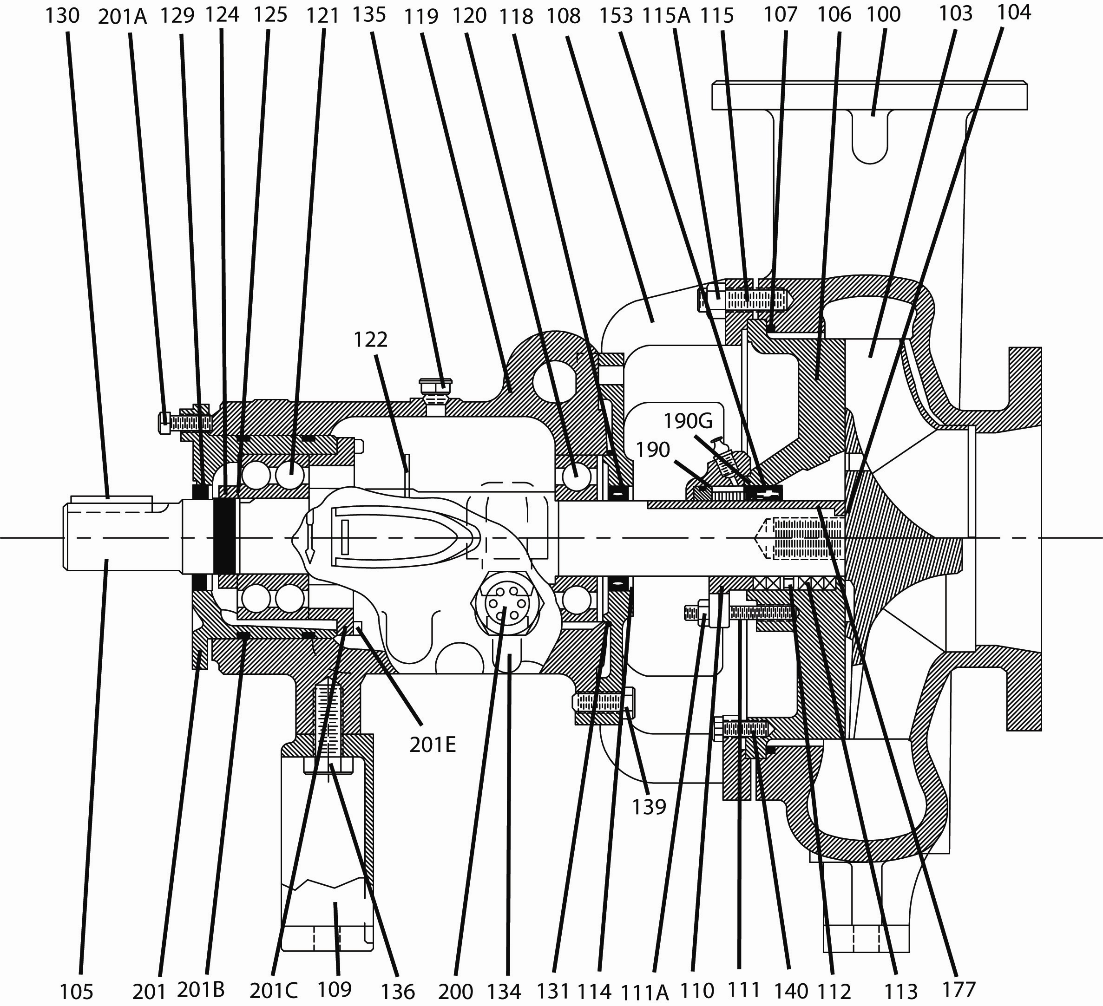

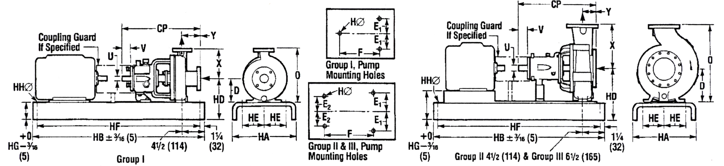
(Do not use for construction purposes unless certified)

Pump Group | ANSI Desig. | Model | Pump Dimensions
Pump Group | ANSI Desig. | Model | Pump Weight  lb (kg) | X  in  (mm) | O  in  (mm) | D  in  (mm) | E₁  in  (mm) | E₂  in  (mm) | CP  in  (mm) | F  in  (mm) | H  In  (mm) | U |  | V Min.  in  (mm) | Y  in  (mm)
 |  |  |  |  |  |  |  |  |  |  |  | Dia.  in (mm) | Keyway  in (mm) | V Min.  in  (mm) | Y  in  (mm)
GP I  1L |  | 1J1x1½LF-4 | 103 (47) | 6½ (165) | 11¾ (298) | 5¼ (133) | 3 (76) | 0 | 17½ (445) | 7¼ (184) | ⅝ (16) | ⅞ (22.23) | ³/₁₆ x ³/₃₂  (4.76 x 2.38) | 2 ³/₁₆ (56) | 4 (102)
GP I  1L | AA | 1L1x1½-6 | 97 (44) |  |  |  |  |  |  |  |  |  |  | 2 (51) | 4 (102)
GP I  1L | AB | 1L1½x3-6 | 112 (51)
GP I  1L | A10 | 1L2x3-6 | 116 (53)
GP I  1L |  | 1L1x1½LF-8 | 103 (47) |  |  |  |  |  |  |  |  |  |  | 2 ³/₁₆ (56) | 4 (102)
GP I  1L | AA | 1L1x1½-8 | 103 (47) |  |  |  |  |  |  |  |  |  |  | 2 (51) | 4 (102)
GP I  1L |  | 1L1½x3-8 | 124 (56) | 7½ (190.5) | 14½ (368) | 7 (177.8)
GP II  2L | A60 | 2L2x3-8 | 200 (90) | 9½ (242) | 17¾ (450) | 8¼ (210) | 4⅞ (124) | 3⅝ (92) | 23½ (597) | 12½ (318) | ⅝ (16) | 1⅛ (28.58) | ¼ x ⅛ (6.35x3.18) | 2⅝ (67) | 4 (102)
GP II  2L | A70 | 2L3x4-8 | 227 (103) | 11 (280) | 19¼ (490) |  |  |  |  |  |  |  |  | 2¾ (70) | 4 (102)
GP II  2L |  | 2L1x2LF-10 | 210 (95) | 8½ (216) | 16¾ (425) |  |  |  |  |  |  |  |  | 2⅝ (67) | 4 (102)
GP II  2L | A05 | 2L1x2-10A | 210 (95) | 8½ (216) | 16¾ (425)
GP II  2L | A50 | 2L1½x3-10A | 220 (100) | 8½ (216) | 16¾ (425)
GP II  2L | A60 | 2L2x3-10A | 226 (103) | 9½ (242) | 17¾ (450)
GP II  2L | A70 | 2L3x4-10 | 225 (101) | 11 (280) | 19¼ (490)
GP II  2L | A70 | 2L3x4-10H | 249 (112) | 12½ (318) | 22½ (572) | 10 (254)
GP II  2L | A80 | 2L4x6-10 | 290 (130) | 13½ (343) | 23½ (597) |  |  |  |  |  |  | 1½ (38.1) | ³/₈ x ³/₁₆ (9.5x4.76) | 2⅝ (67) | 4 (102)
GP II  2L | A80 | 2L4x6-10H | 328 (149) | 13½ (343) | 23½ (597)
GP II  2L |  | 2L1½x3LF-13 | 250 (112) | 10½ (266) | 20½ (520) |  |  |  |  |  |  | 1⅛ (28.58) | ¼ x ⅛ (6.35x3.18) | 2¾ (70) | 4 (102)
GP II  2L | A20 | 2L1½x3-13 | 250 (112) | 10½ (266) | 20½ (520) |  |  |  |  |  |  |  |  | 2⅝ (67) | 4 (102)
GP II  2L | A30 | 2L2x3-13 | 258 (116) | 11½ (292) | 21½ (546)
GP II  2L | A40 | 2L3x4-13 | 281 (126) | 12½ (318) | 22½ (572)
GP II  2L | A40 | 2L3x4-13HH | 281 (126) | 12½ (318) | 22½ (572)
GP II  2L | A80 | 2L4x6-13A | 324 (145) | 13½ (343) | 23½ (597)
GP III  3L | A90 | 3L6x8-14 | 680 (306) | 16 (406) | 30½ (775) | 14½ (368) | 8 (203.2) | 4½ (114.3) | 33⅞ (860) | 18¾ (476) | ⅞ (22.23) | 2⅜ (60.33) | ⁵/₈ x ⁵/₁₆ (15.88x7.94) | 4 (102) | 6 (152)
GP III  3L | A100 | 3L8x10-14 | 899 (408) | 18 (457) | 32½ (826)
GP III  3L |  | 3L4x6-16 | 641 (291) | 16 (406) | 30½ (775)
GP III  3L | A110 | 3L6x8-16A | 832 (377) | 18 (457) | 32½ (826)
GP III  3L | A120 | 3L8x10-16 | 917 (416) | 19 (483) | 33½ (851)
GP III  3L | A120 | 3L8x10-16H | 992 (450) | 19 (483) | 33½ (851)
GP III  3L |  | 3L8x10-17 | 835 (379) | 20 (508) | 34½ (876)

Pump Group | Baseplate | Max. Motor Frame | Baseplate Mounting Dimensions
Pump Group | Baseplate | Max. Motor Frame | Weight  lb  (kg) | HA  in  (mm) |  | HB  in  (mm) | *HD₁▲  in  (mm) |  | *HD₂▲  in  (mm) |  | HE  in  (mm) | HF  in  (mm) | **HG  in  (mm) |  | HH  in  (mm)
 |  |  |  | Metal | Poly. | HB  in  (mm) | Metal | Poly. | Metal | Poly. | HE  in  (mm) | HF  in  (mm) | Metal | Poly. | HH  in  (mm)
GP I  1L | 139 | 184T | 111 (50) | 15 (381) | 13 (330) | 39 (991) | 9 (229) | 8⅞ (226) | 10¾ (273) | 10⅝ (269) | 4½ (114) | 36½ (927) | 3¾ (95) | 3⅝ (92) | ¾ (19)
GP I  1L | 148 | 215T | 163 (74) | 18 (457) | 16 (406) | 48 (1219) | 9½ (241) | 9⅜ (238) | 11⅛ (283) | 11 (280) | 6 (152) | 45½ (1156) | 4⅛ (105) | 4 (102) | ¾ (19)
GP I  1L | 148 | 256T |  |  |  |  | 10½ (267) | 10⅜ (264)
GP I  1L | 153 | 286T | 212 (96) | 21 (533) | 19 (483) | 53 (1346) | 11⅞ (302) | 11⅛ (283) | 11⅞ (302) | 11⅛ (283) | 7½ (191) | 50½ (1283) | 4¾ (121) | 4 (102) | ¾ (19)
GP I  1L | 153 | 326TS |  |  |  |  | 12⅞ (327) | 12⅛ (308) | 12⅞ (327) | 12⅛ (308)
GP II  2L | 245 | 184T | 129 (59) | 15 (381) | 13 (330) | 45 (1143) | 12 (305) | 11⅞ (302) | 13¾ (349) | 13⅝ (346) | 4½ (114) | 42½ (1080) | 3¾ (95) | 3⅝ (92) | ¾ (19)
GP II  2L | 252 | 215T | 177 (80) | 18 (457) | 16 (406) | 52 (1321) | 12⅜ (319) | 12 ¼ (312) | 14⅛ (359) | 14 (355) | 6 (152) | 49½ (1257) | 4⅛ (105) | 4 (102) | 1 (25)
GP II  2L | 258 | 286T | 234 (106) | 21 (533) | 19 (483) | 58 (1473) | 13 (330) | 12 ¼ (312) | 14¾ (375) | 14 (355) | 7½ (191) | 55½ (1410) | 4¾ (121) | 4 (102) | 1 (25)
GP II  2L | 264 | 326T | 328 (149) | 22 (559) | 22 (559) | 64 (1626) | 13 (330) | 12 ¼ (312) | 14¾ (375) | 14 (355) | 7½ (191) | 61½ (1562) | 4¾ (121) | 4 (102) | 1 (25)
GP II  2L | 264 | 365T |  |  |  |  | 13⅞ (352) | 13⅛ (334)
GP II  2L | 268 | 405TS | 409 (186) | 26 (660) | 26 (660) | 68 (1727) | 14⅞ (378) | 14⅜ (365) | 14⅞ (378) | 14⅜ (365) | 9½ (241) | 65½ (1664) | 4¾ (121) | 4¼ (108) | 1 (25)
GP II  2L | 280 | 449TS | 481 (218) | 26 (660) | 26 (660) | 80 (2032) | 15⅞ (403) | 15⅜ (365) | 15⅞ (403) | 15⅜ (365) | 9½ (241) | 77½ (1969) | 4¾ (121) | 4¼ (108) | 1 (25)
GP III  3L | 368 | 286T | 470 (213) | 26 (660) | 26 (660) | 68 (1727) | 19¼ (489) | 19 (483) |  |  | 9½ (241) | 65½ (1664) | 12⅛ (308) | 4¼ (108) | 1 (25)
GP III  3L | 380 | 405T | 601 (273) | 26 (660) | 26 (660) | 80 (2032) |  |  |  |  |  | 77½ (1969) | 9⅛ (232) | 4¼ (108) | 1 (25)
GP III  3L | 398 | 449T | 746 (338) | 26 (660) | 26 (660) | 98 (2489) |  |  |  |  |  | 95½ (2426) | 8⅛ (206) | 4¼ (108) | 1 (25)
*GP I | – HD₂ applies to 1½x3-8 only. |  |  |  |  |  |  |  | ▲ Includes spacer under pump, as necessary
GP II | – HD₁ applies to 2x3-8, 3x4-8, 1x2-10A, 1½x3-10A, 2x3-10A and 3x4-10. |  |  |  |  |  |  |  | ** “HG” dimension applied to the lower pad height. With some bases this will occur at
 | – HD₂ applies to 3x4-10H, 4x6-10, 4x6-10H, 1½x3-13, 2x3-13, 3x4-13, 3x4-13HH and 4x6-13A. |  |  |  |  |  |  |  | pump end and with others at motor end.
GP III | – HD₁ applies to all GP III sizes.
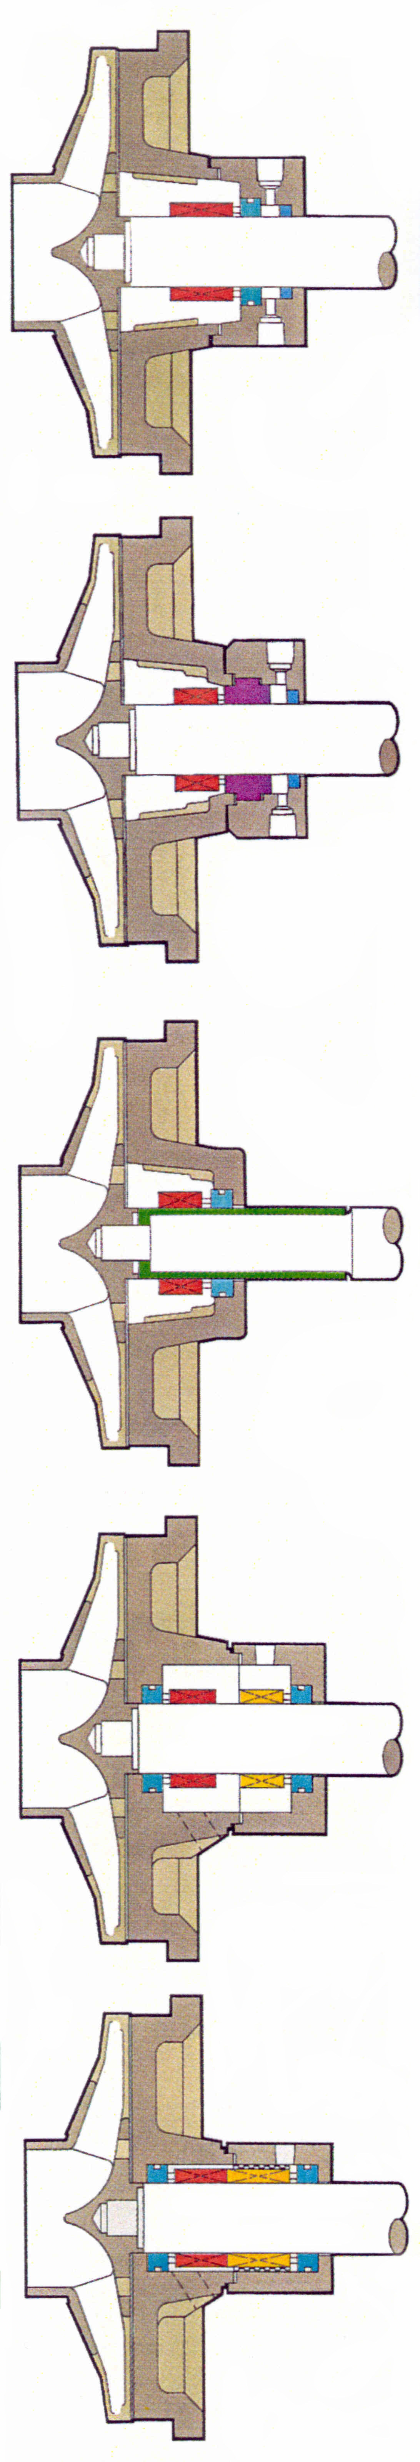

FML  Oversized, tapered bore with 8 specially shaped and evenly spaced cast-in flow modifiers. Designed for seals with large gland bolt and gasket circles. | • Single internal cartridge seals.  • Dual internal/external cartridge seals.  • Single internal component seals with flexibly mounted seats.*  • Dual internal “true” tandem cartridge seals.  Note: Bypass flush to internal seal normally not required. Barrier fluid or external flush may apply to dual seals (Plans 52, 53, etc.).
FMS  Same chamber design as FML but accommodates seals with small gland bolt and gasket circles. | Same seal and flush plan recommendations as for FML. Single seals with all types of seat mounting configurations can be installed. FMS design is provided for the convenience of customers with seal standards that include small glands. This design is American-Marsh’s secondary recommendation to the FML.*
FMI  Same chamber design as FMS, but includes a cast-in integral gland. | • Single internal, flexibly mounted seals. Uses sleeve for seal setting and fast installation.  • “Sanitary-type” applications. Less prone to bacteria build up.  Note: Bypass flush is normally not required.
CBL  Oversized, cylindrical step bore design for seals with large gland bolt and gasket circles. | • Dual internal component seals. Isolates the seal chamber from the process. Allows less expensive seal materials. Recommended in tough slurry applications.  Note: Use External Flush Plan 54. Others (i.e., Plans 52, 53) not recommended without close tolerance pumping mechanism.  • Single internal component or cartridge seals when applied with a throat bushing. Usually selected to increase stuffing box pressure above the vapor pressure to avoid cavitation, etc.  Note: Applied with Plan 11, etc.
CBS  Cylindrical bore design for packing arrangements and conventional seals with small gland bolt and gasket circles. | • Dual internal component seals. Isolates the seal chamber from the process. Allows less expensive seal materials. Recommended in tough slurry applications. Allows for thermal convection type flush plans; however, pumping ring devices are recommended.  Note: External Flush Plans 52, 53, 54  • Single internal component or cartridge seals when applied with a throat bushing. Usually selected to increase stuffing box pressure above the vapor pressure to avoid cavitation, etc.  • Usually preferred over the CBL when jacketing is selected for increased effectiveness in cooling or heating.  Note: Applied with Plan 11, etc.
*All seal selections perform best when the faces are located directly within the flush path, particularly if solids, liquors, or slurries are present. Component seals with clamped seat gland designs locate the seal faces reasonably well. Flexibly mounted seat glands should include the vent and drain option to better locate the seal faces. The FML is always the first-choice chamber for maximum self-flush path benefits.

FML
FMS
FMI
CBS
CBL
Sales & Marketing: 185 Progress Road • Collierville, Tennessee • 38017
Manufacturing: 185 Progress Road • Collierville, Tennessee • 38017
Phone: (800) 888-7167
Fax: (901) 860-2323
- Your Local Authorized Distributor -

